AWS Administrative Access
Access aws from rover apps , search aws , click on aws console

The installer requires access to provision of resources.
- Create an IAM user with programmatic access keys (AWS_ACCESS_KEY_ID and AWS_SECRET_ACCESS_KEY).
- Create User from aws console
- Click create user in iam
- Select admin role
- Set default remaining things
- Create the user
- Export these keys to your local machine terminal:
- Bash
export AWS_ACCESS_KEY_ID="AKIAxxxxxxxxxxxx"
- export AWS_SECRET_ACCESS_KEY="wJalrXUtnFEMI/K7MDENG/bPxRfiCYEXAMPLEKEY"
- 

. SSH Key Configuration
You must provide an SSH key to enable fallback debugging access to the underlying Red Hat Enterprise Linux CoreOS (RHCOS) nodes.
Bash
ssh-keygen


D. Red Hat Pull Secret
Log into the Red Hat Hybrid Cloud Console, navigate to the OpenShift deployment page, and download your unique Pull Secret. This token validates your subscription and grants authorization to pull container images from the quay.io and registry.redhat.io registries.

2. Setting Up the Local Environment
Instead of invoking deployment directly from a local laptop where network stability can vary, it is best practice to run this execution from a temporary Linux instance (Bastion host) running inside your target cloud environment.
Download and unpack the core binaries (the OpenShift Installer and the OpenShift Command-Line tool oc):
Bash
# Download Installer and CLI (Adjust versions dynamically based on your requirements)
wget https://mirror.openshift.com/pub/openshift-v4/x86_64/clients/ocp/stable/openshift-install-linux.tar.gz
wget https://mirror.openshift.com/pub/openshift-v4/x86_64/clients/ocp/stable/openshift-client-linux.tar.gz

# Extract binaries
tar -xvf openshift-install-linux.tar.gz
tar -xvf openshift-client-linux.tar.gz

# Move to system execution path
sudo mv openshift-install oc kubectl /usr/local/bin/

3. The Internal Provisioning Architecture Execution
Once configured, launch the fully automated build execution script:
Bash
openshift-install create cluster


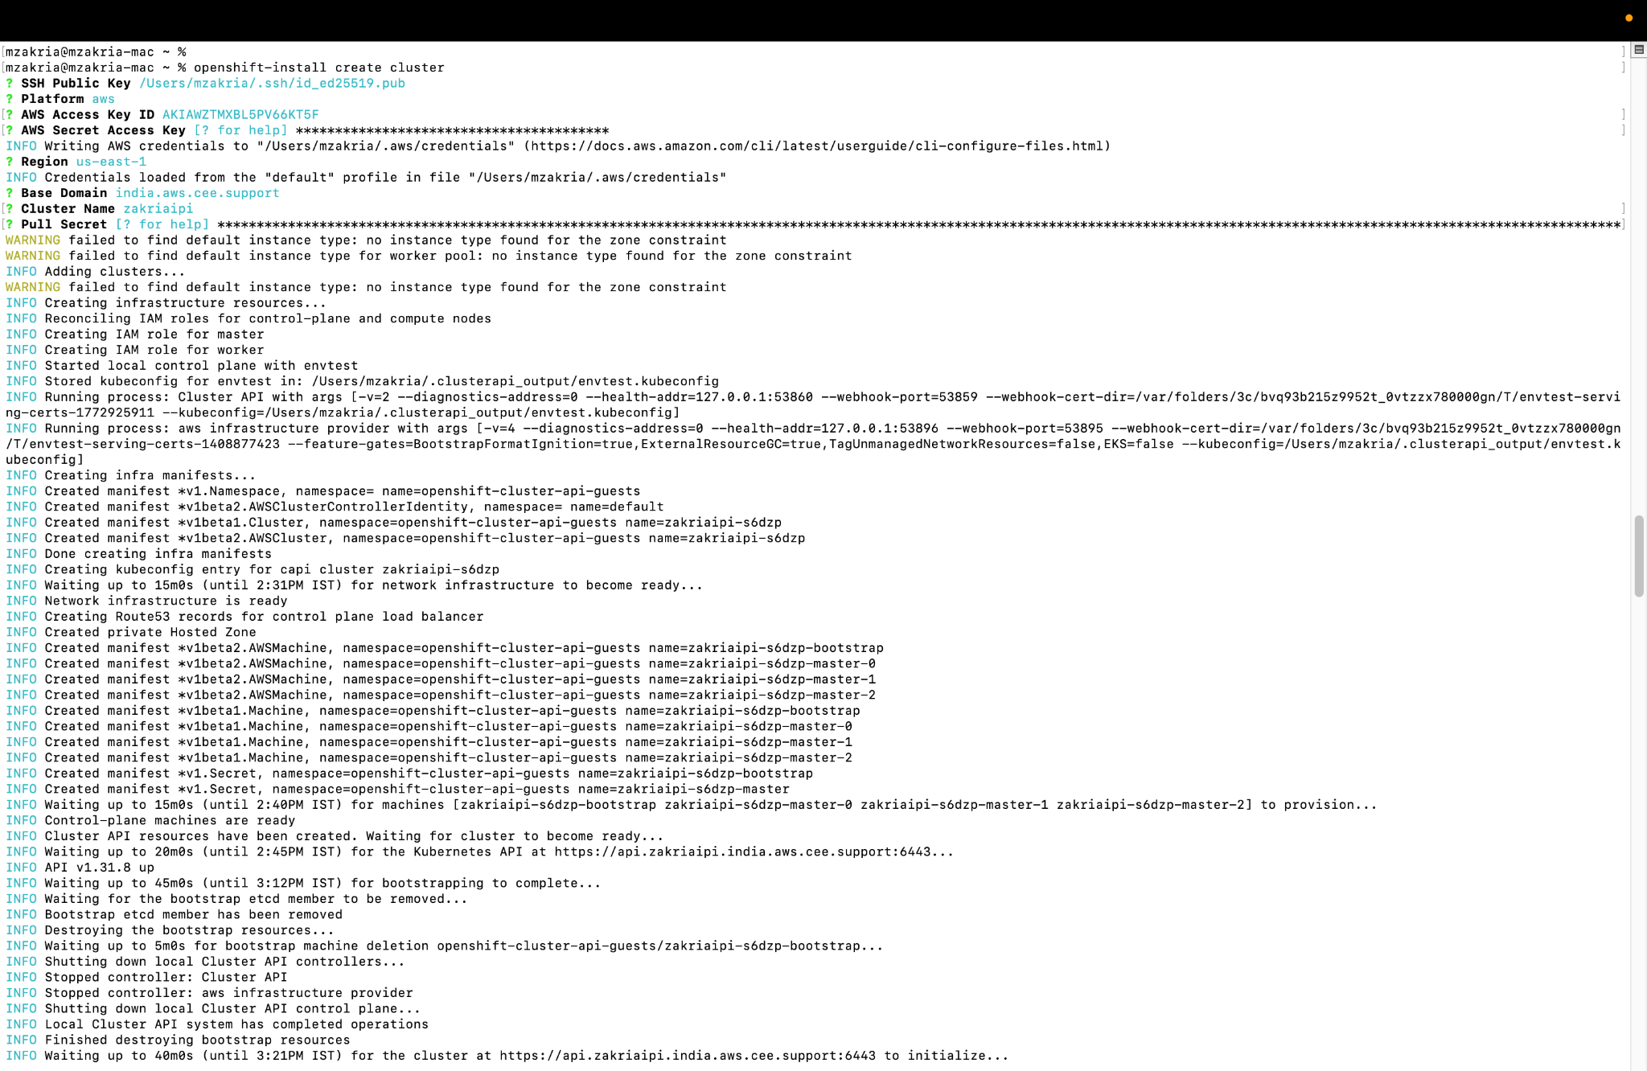

After the cluster credentials are handy with kubeadmin

Login to cluster with kubeadmin

Install Advanced Cluster Management for Kubernetes from installed operator

It will ask for install one more operator multicluster engine for Kubernetes , installl that

